Module 6: S3 Website Hosting Assignment
Problem Statement:
You work for XYZ Corporation. Their application requires a storage service that can store files and publicly share them if required. Implement S3 for the same.
Tasks To Be Performed:
1. Use the created bucket in the previous task to host static websites, upload an index.html file and error.html page.
2. Add a lifecycle rule for the bucket:
a. Transition from Standard to Standard-IA in 60 days
b. Expiration in 200 days
1.Uploading the index.html file and error.html pages into the bucket assignment-01-june:
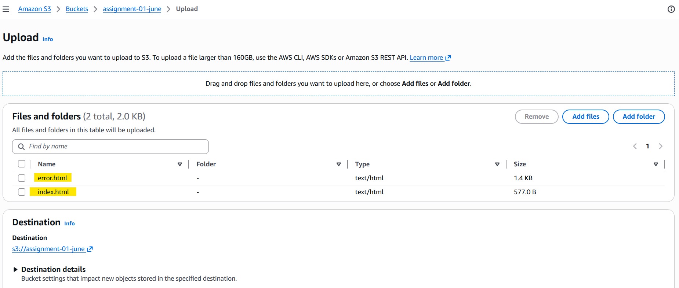

2. Both pages are uploaded successfully:
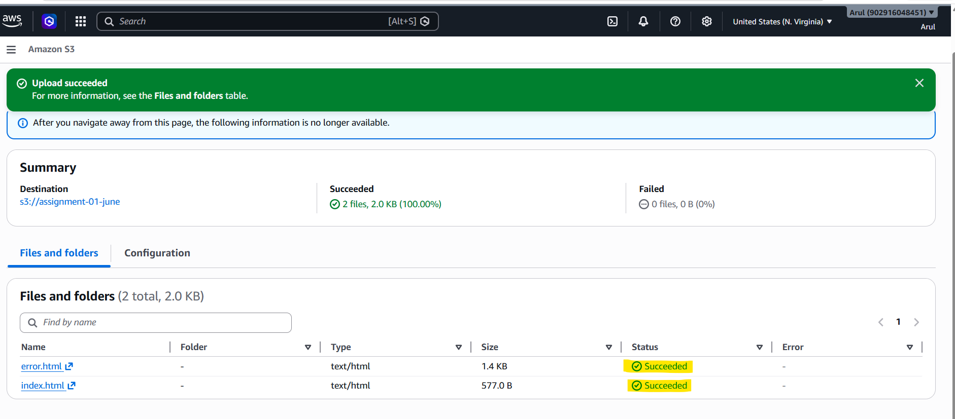

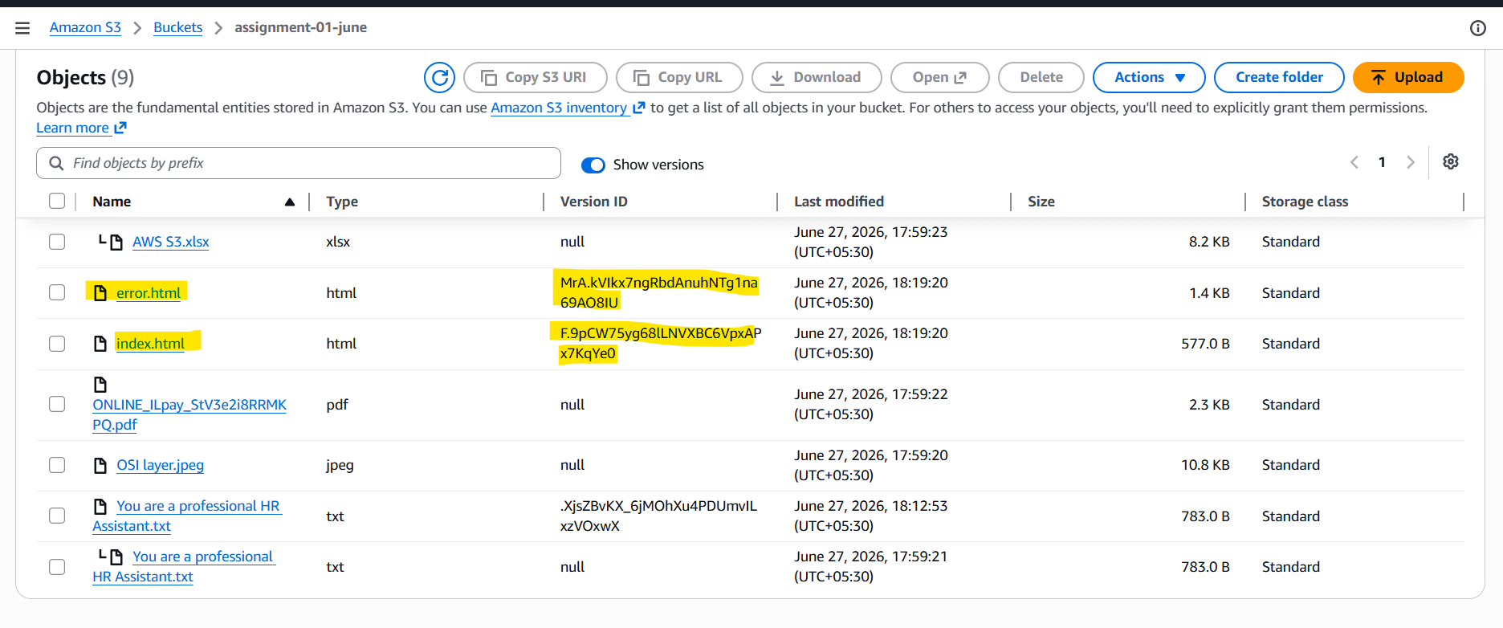
3.Enable Public Access for the bucket under the permission tab:
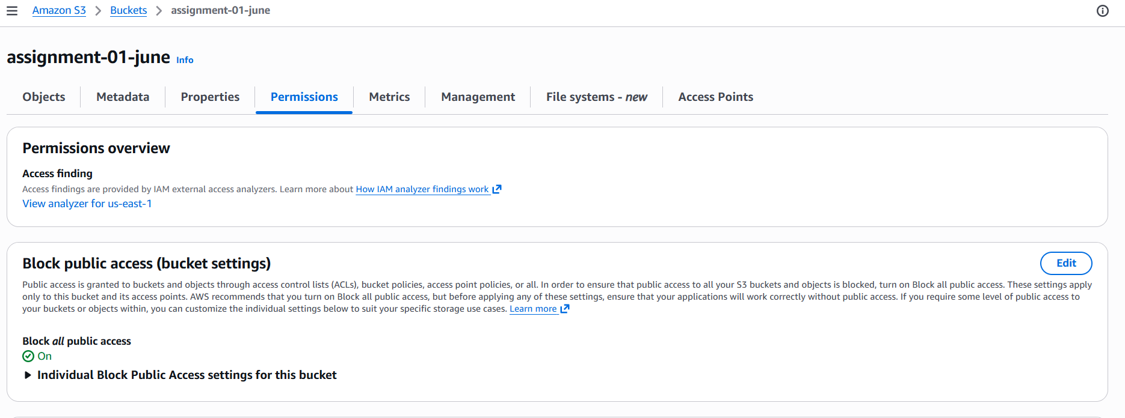
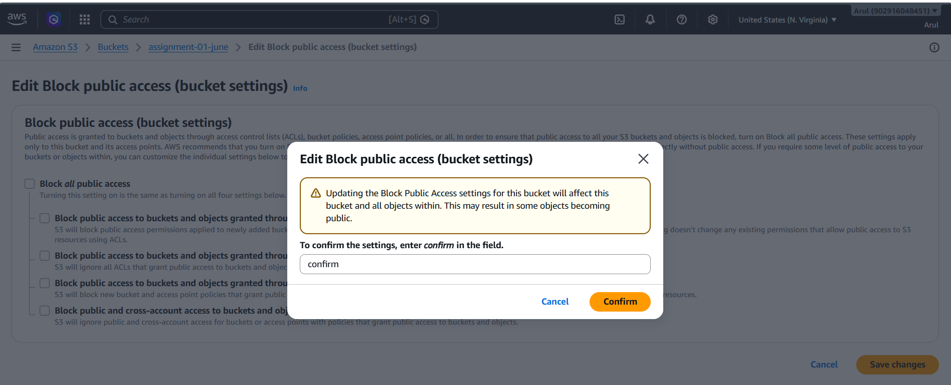

4.Enable ACL for the object:
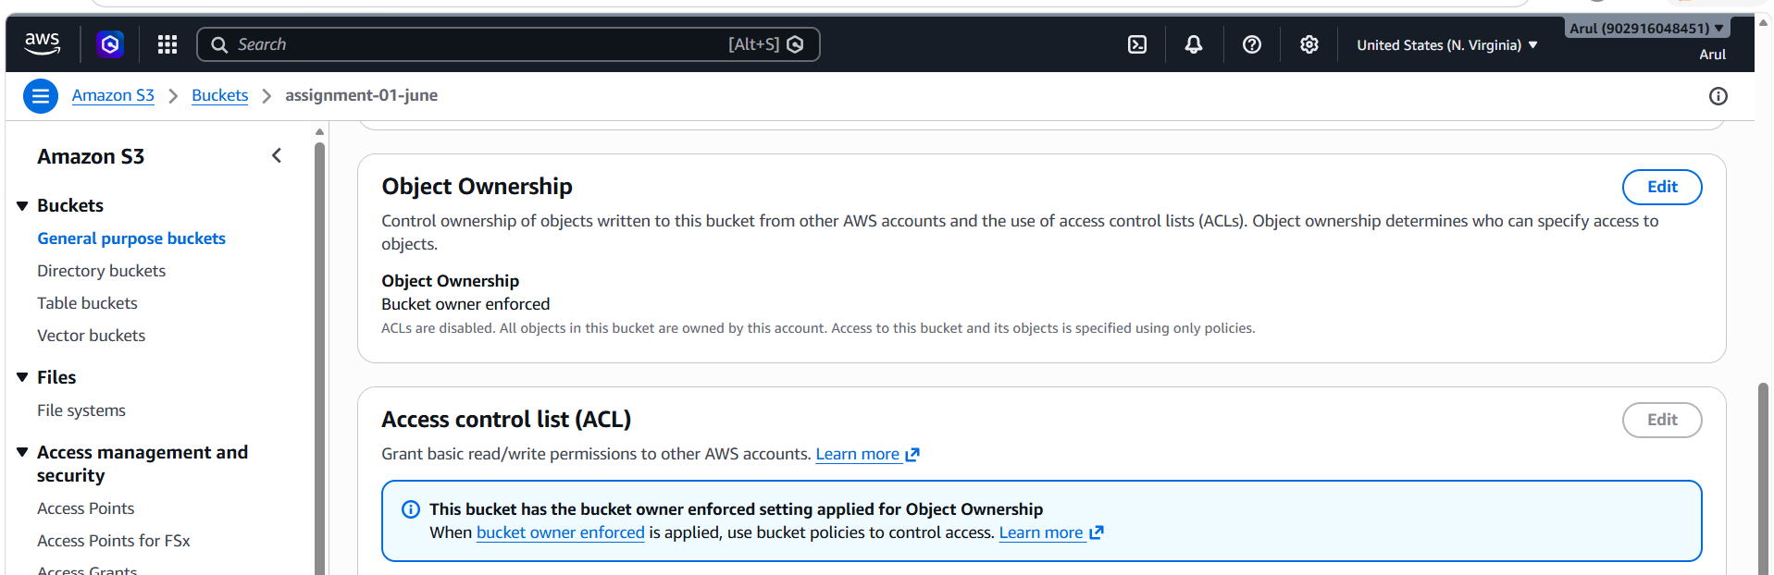
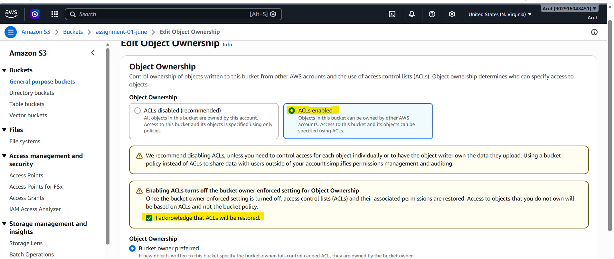

5.Make Public using ACL for index.html
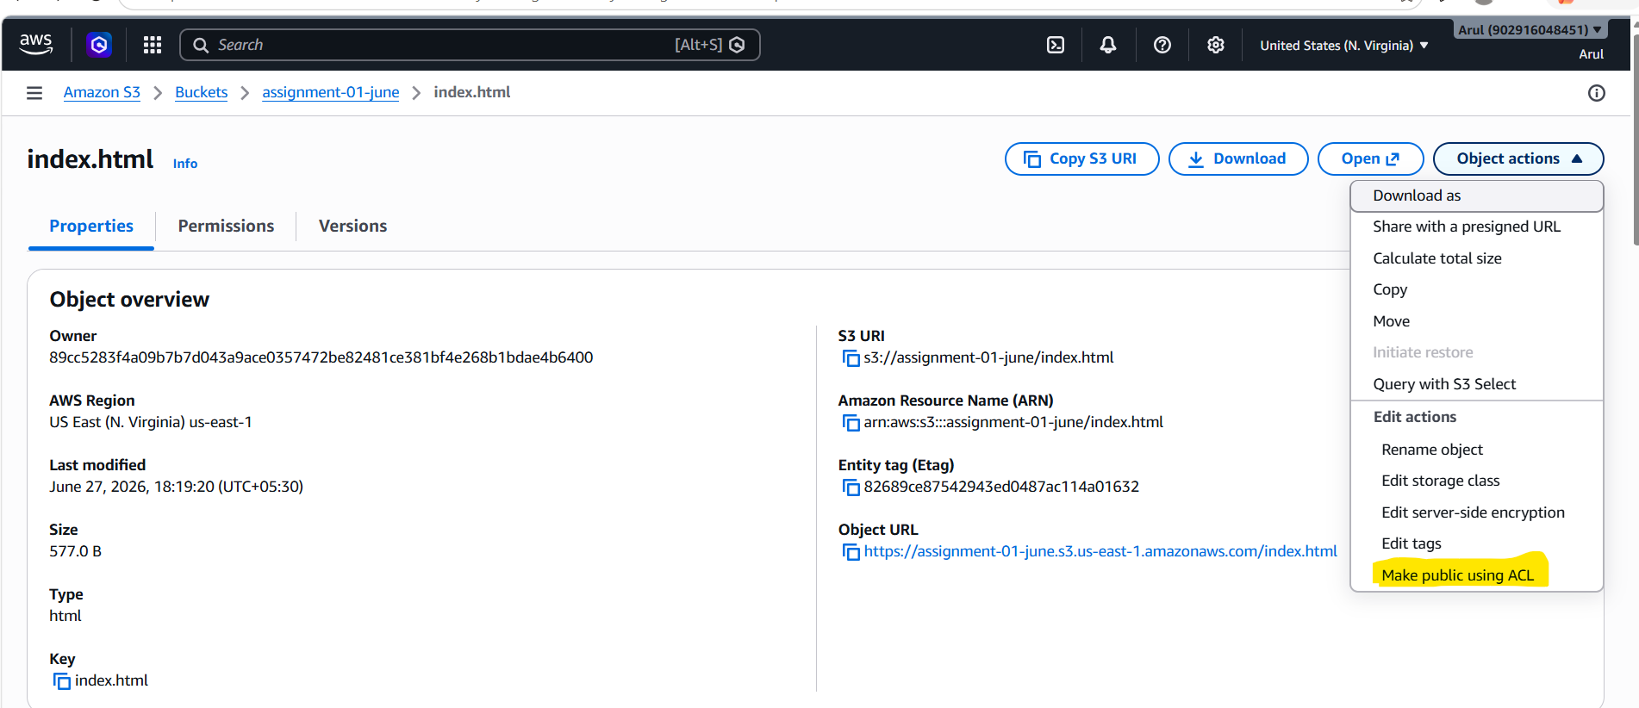

6.Make Public using ACL for error.html
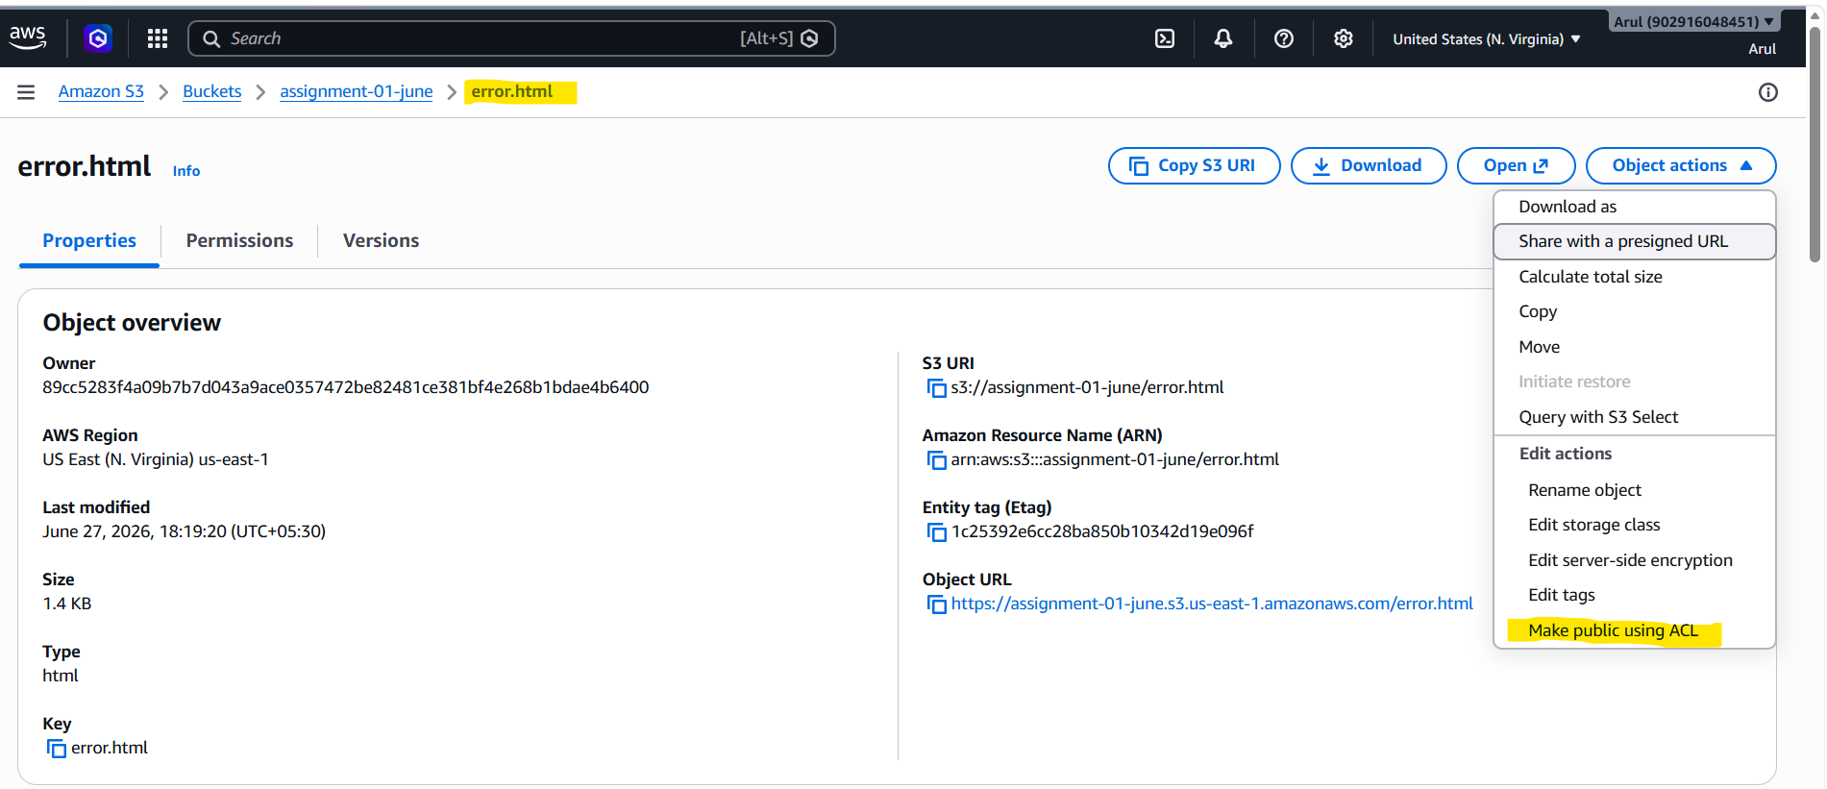
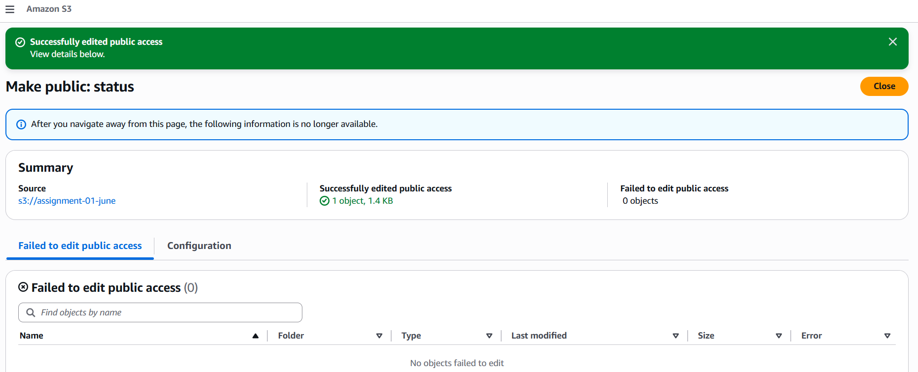
Index.html https://assignment-01-june.s3.us-east-1.amazonaws.com/index.html
error.html https://assignment-01-june.s3.us-east-1.amazonaws.com/error.html
7.Go to Bucket Properties Edit static website hosting and specify the index and error web page files.
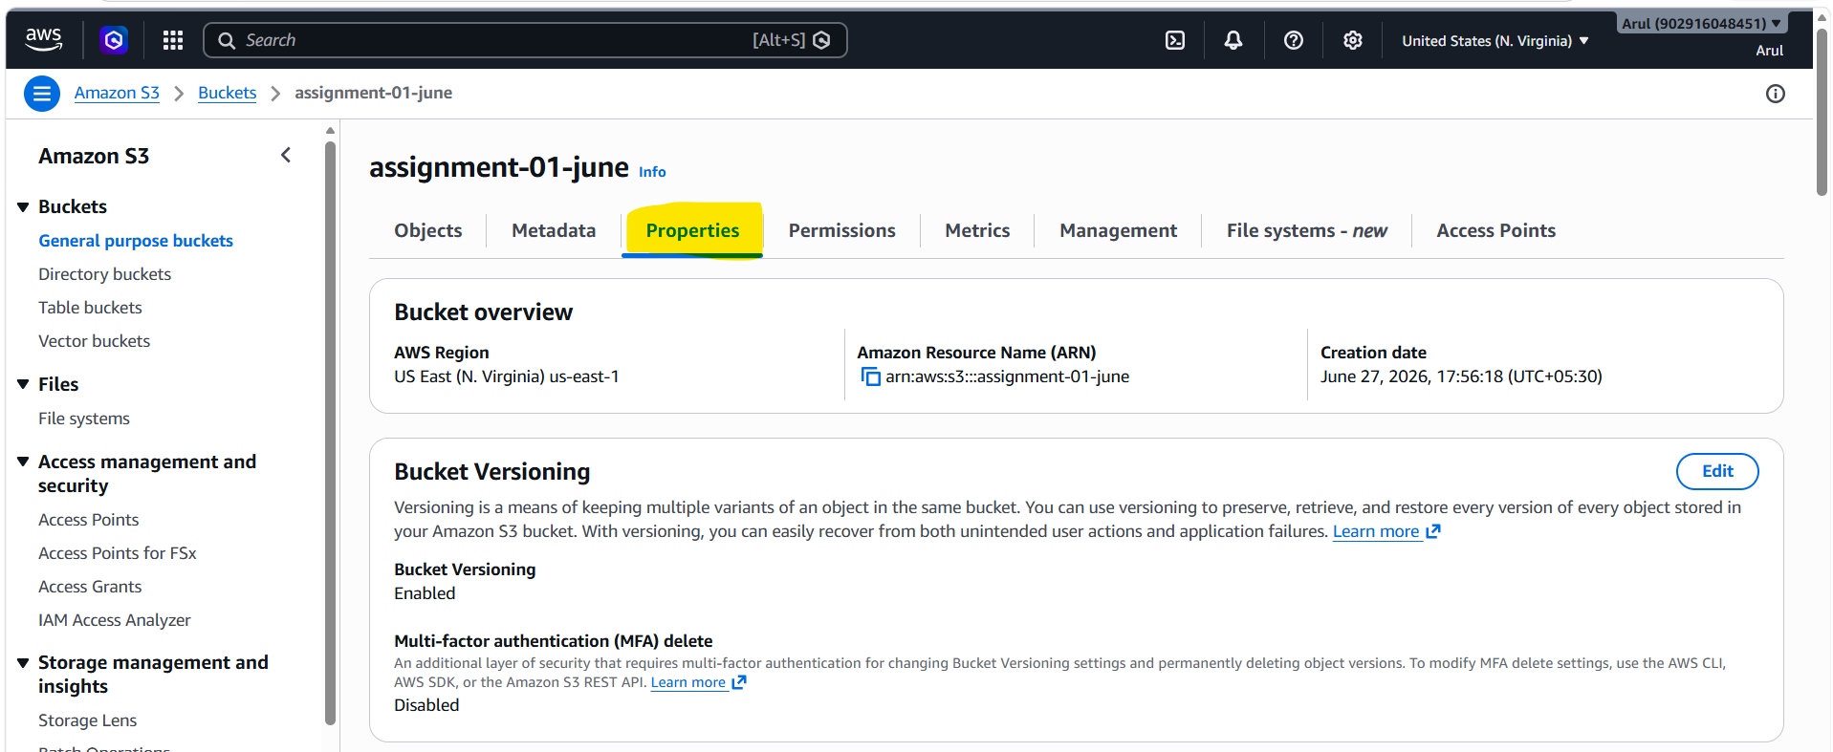
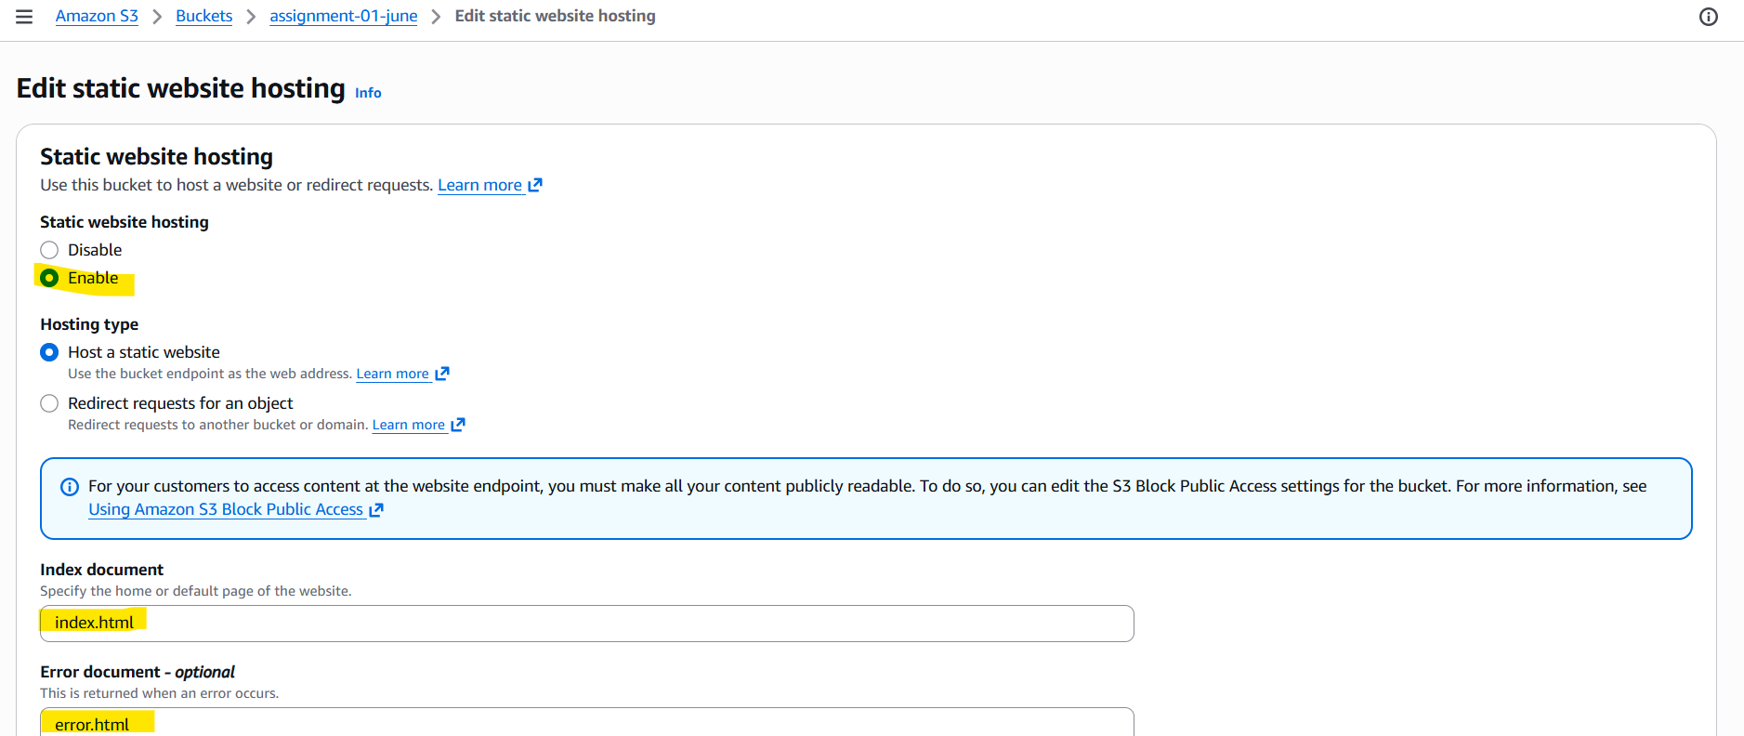
7. Enabled S3 static website hosting:
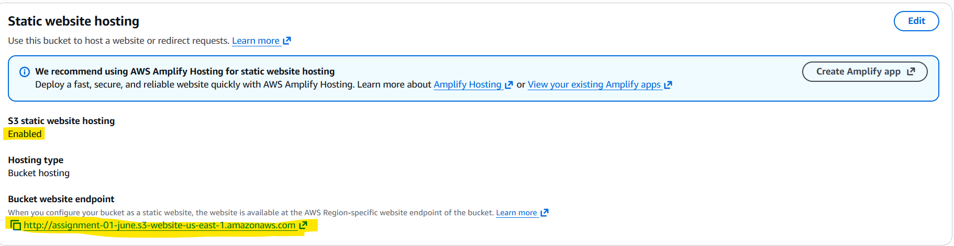
Webpage URL: http://assignment-01-june.s3-website-us-east-1.amazonaws.com/
8. index.html page is accessible over the browser:
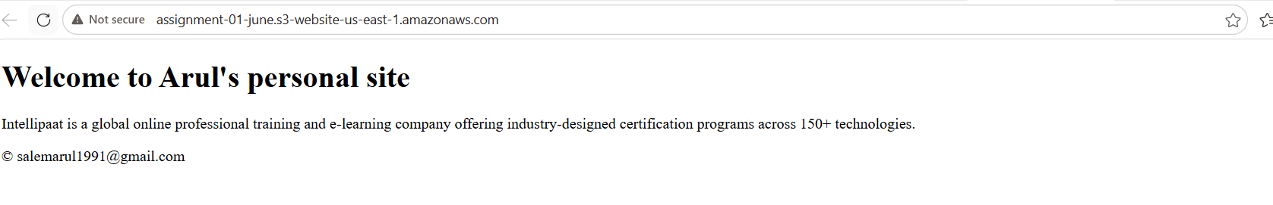
9. Replace index.html file with a unknown file called “hello” to verify error.html page:
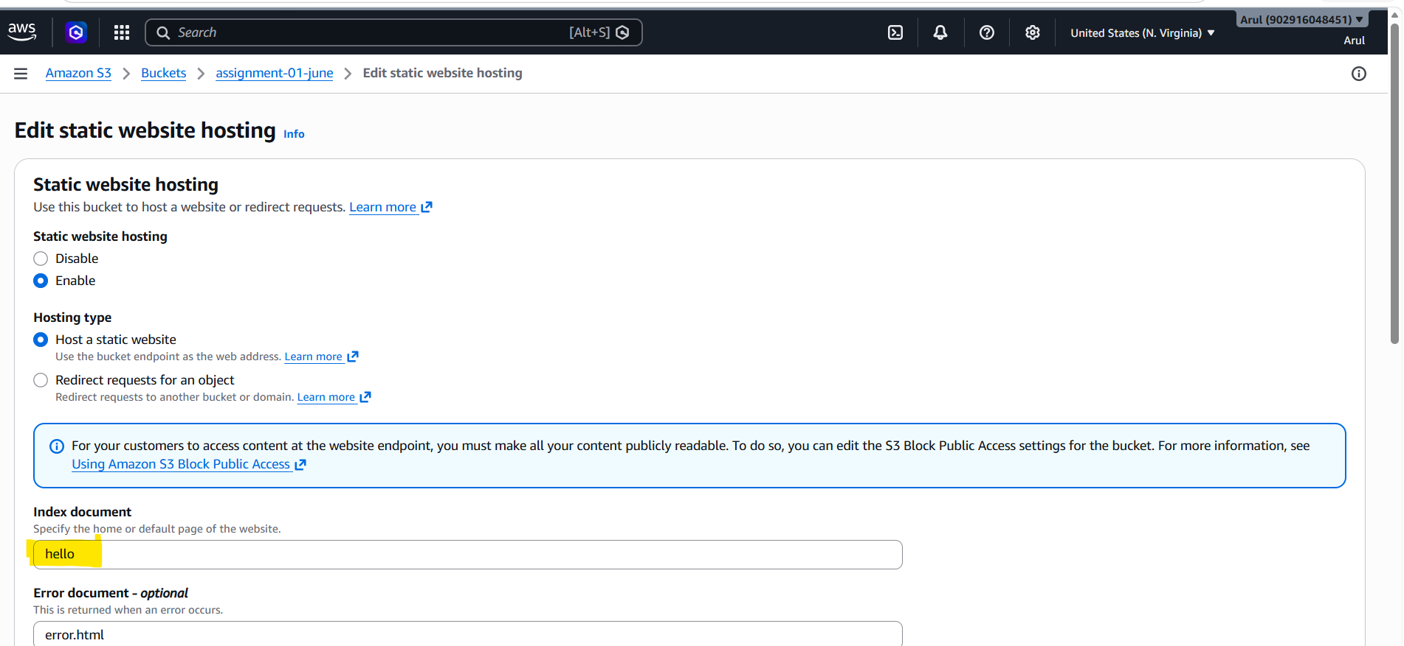

10. error.html page is accessible over the browser:
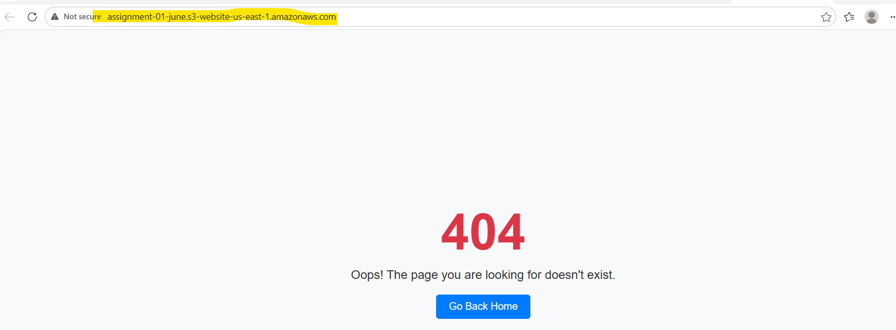

11. Select the Bucket Management Create lifecycle rule
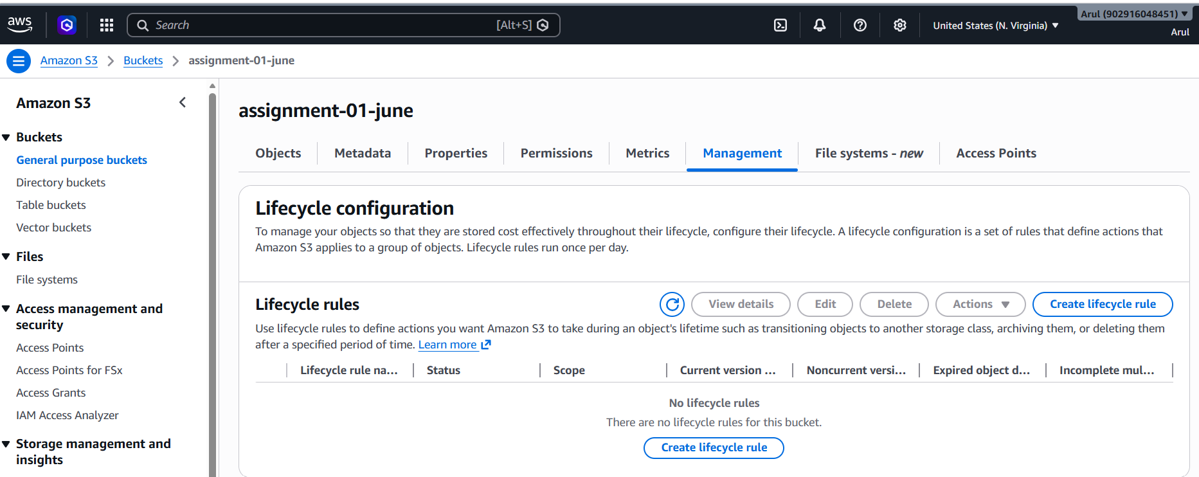

12. Specify the rule name & rule scope:
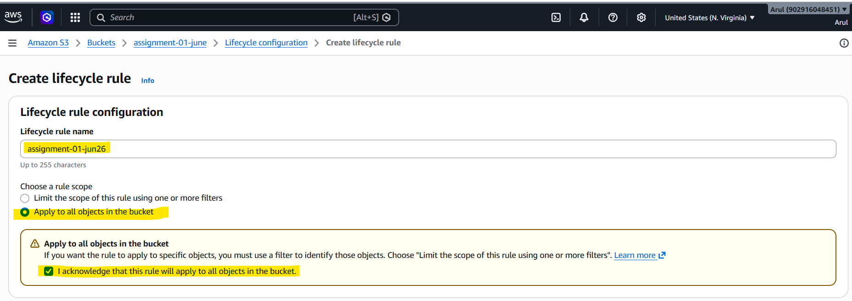

13.Enable the transition and expire options:
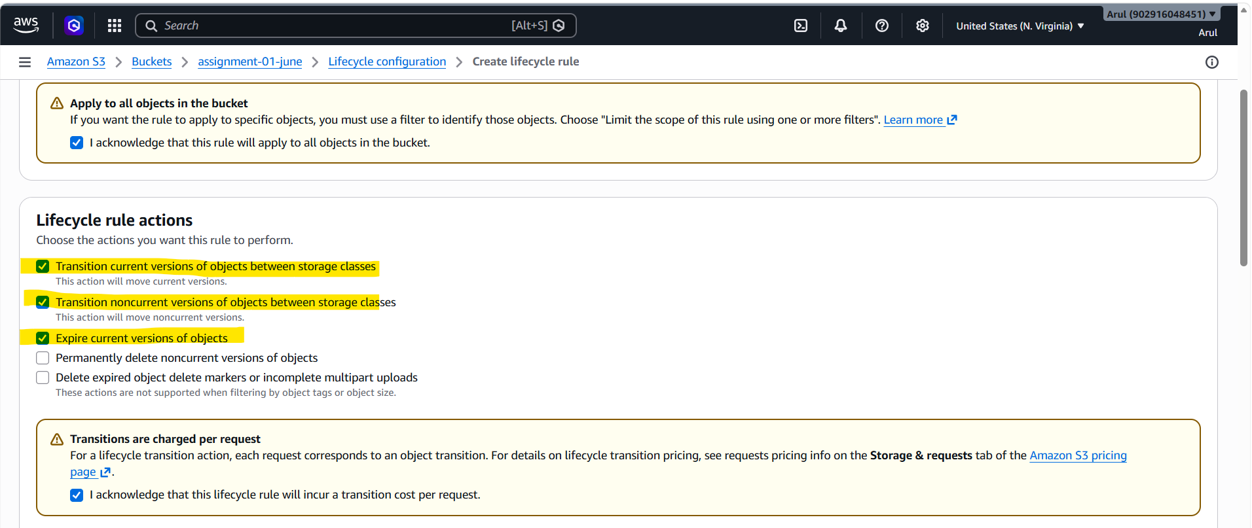

14. Add Transition from Standard to Standard-IA in 60 days
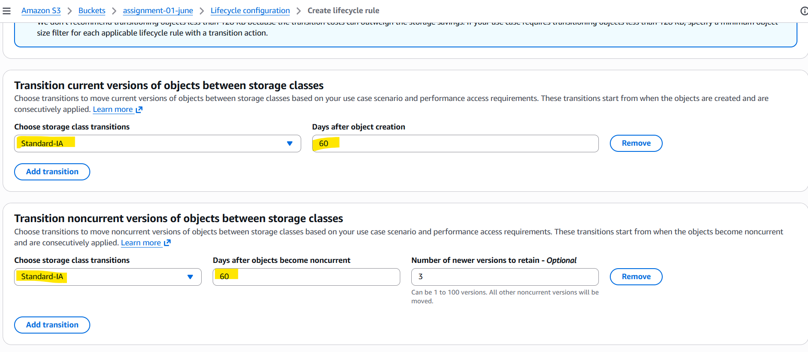
15. Set expiration in 200 days and review the summary:
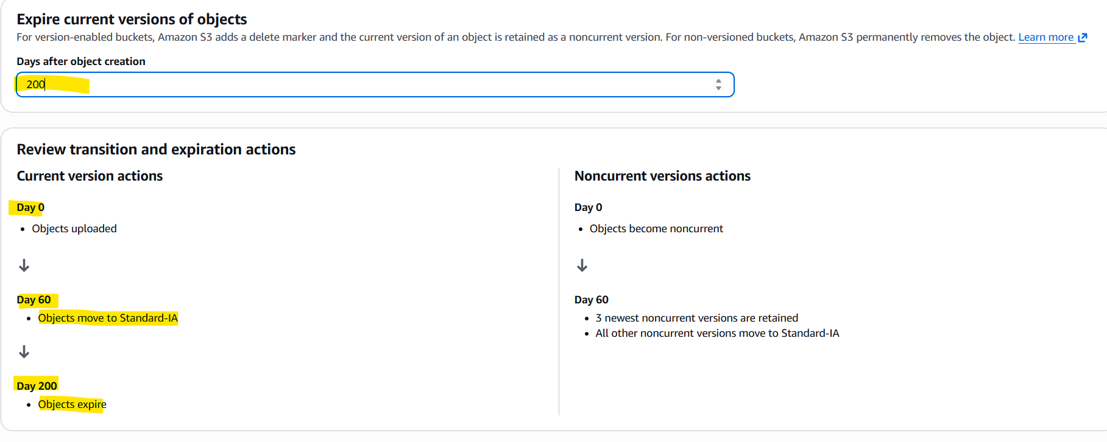

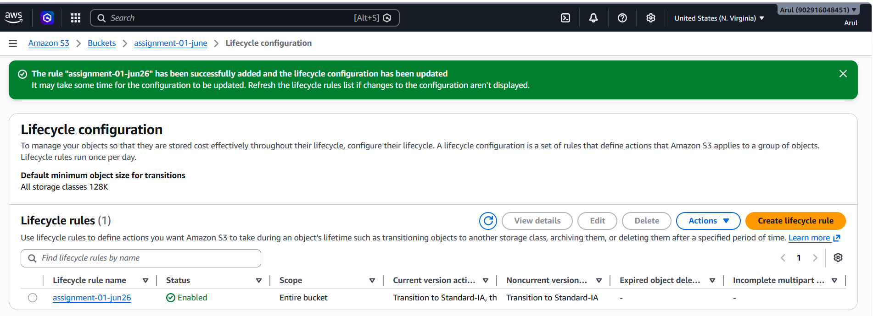
16. Validate the rule:
